8-11 Formative
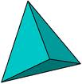
- Identify the figure above. Identify number of faces, vertices, and edges.
Name of figure:_________________
# of faces _____________
# of vertices ______________
# of edges ___________
- Does a pyramid ever have parallel sides? Explain your reasoning.

- Draw a mat plan for the 3-D figure below.
Then draw the front view, side view, and top view.

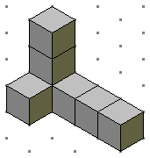

Mat plan:

Front view:

Side view:

Top view:

- Use the mat plan below to draw a 3-D figure on isometric dot paper.
3
2
22
2

2
2
1
1
1

