**Mathematics**

**Power Standard 8:7**

**Summative Scoring Guide**

1. C
2. B
3. A
4. D
5. $\frac{-x}{3}$ = - 9

-x = - 27

X = 27

2 points: Exemplary response; correct steps and correct answer

1 point: Either correct answer or correct steps, but not both

0 point: Neither correct answer nor correct steps.

1. 50 x + 100 = 300

50 x = 200

X = 4 hours

3 points: Exemplary response; correct equation, steps, and correct answer

2 points: Two of the above

1 point: One of the above

1. point: None of the above criteria correct
2. m = - 3, b = 4

2 points: Exemplary response: correct slope and correct y-intercept

1 point: correct slope or correct y-intercept, but not both

1. point: neither slope nor y-intercept is correct
2. y = ($\frac{1}{2}$)x - 2

3 points: Exemplary response; correct form, correct slope and correct y-intercept

2 points: Two of the above

1 point: One of the above

1. point: None of the above criteria correct
2. m = - ($\frac{1}{2}$), b = 2

3 points: Exemplary response: Correct graph, correct slope, and correct y-intercept

2 points: 2 of the above criteria correct

1 point: 1 of the above criteria correct

0 point: none of the above criteria correct

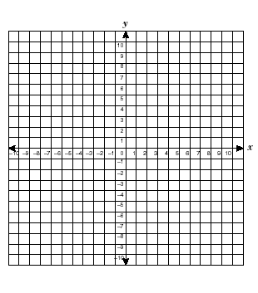

1. 60 words per minute; all reasonable answers should be accepted.



4 points: Exemplary Response: correct graph, reasonable line of fit; reasonable prediction; explanation in words

3 points: 3 of the above criteria correct

2 points: 2 of the above criteria correct

1 point: 1 of the above criteria correct

0 point: none of the above criteria correct

1. 3 envelopes/minute

3 points: Exemplary response: Correct explanation in words; correct answer; answer in reduced form

2 points: Explanation or correct answer but not reduced

1 point: Correct answer but not reduced or explained

0 point: incorrect answer