**Mathematics**

**Power Standard 8:7**

**Post-Formative Test**

**Name ________________________________________________ Hour ________**

1. Describe the following situation: As the temperature outside goes up, the heating bill goes down.
2. positive relationship
3. no relationship
4. negative relationship
5. neutral relationship
6. Solve for x: $\frac{x}{2}$ + 3 = **-**9 Show steps:
7. The student council wants to rent a popcorn machine for their fall party. Popcorn machines can be rented for $20 per hour. In addition to the hourly charge, there is a rental fee of $40. Write and solve an equation showing how long the popcorn machine can be rented if the student council has $160 to spend.
8. Identify the slope and y-intercept of the following:

y = **-** ($\frac{3}{4}$) x - 3

m=_______________ b=_____________________

1. Given the following graph of a linear function, write the equation of the line in slope-intercept form.

Equation: ___________________________

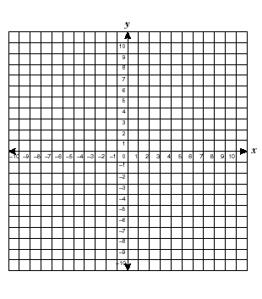

1. Graph y = **-**2x. Identify the slope and y-intercept.

m=____________________ b=________________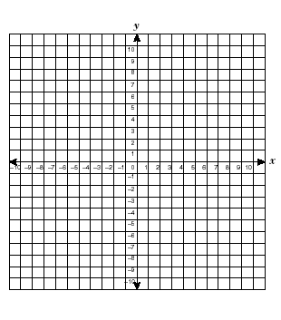

1. Use the following t-bar to make a scatter plot. Use a line of fit to predict the number of words that can be typed in 15 minutes. Explain how you arrived at your prediction.

Minutes Number of words

1. 45
2. 100
3. 130
4. 195
5. 245
6. 305



1. Use the table to answer the following question.

|  |  |  |  |  |
| --- | --- | --- | --- | --- |
| **Time** | 1:00 | 1:05 | 1:10 | 1:20 |
| **Presents Wrapped** | 15 | 25 | 40 | 70 |

What was the rate of change between 1:05 and 1:10? Explain.