Summative answers

1. B
2. A
3. B
4. Example answer: Make a line graph for the following information:

Number of Common Dolphins seen in Santa Barbara Channel from 1996-2001:

1996: 1900

1997: 7600

1998: 4400

1999: 6100

2000: 4800

2001: 7800

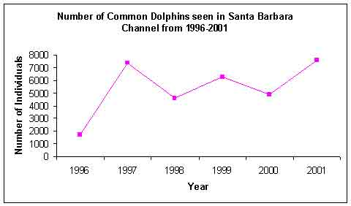

2 points: Exemplary response; line graph titled, x and y axis labeled correctly, information graphed correctly, explanation of usefulness correct.

1 point: 2-3 of the above elements are correct.

1. points: none of the above elements are correct.
2. Example answer: Make a bar graph and don’t start the y-axis counting at “0”, make a bar graph and don’t use consistent intervals, make a picto-graph and use distorted pictures.

2 points: Exemplary response; 2 correct methods explained.

1 point: 1 correct method explained.

0 points: No correct method explained.

1. Example answer: 5,6,7,8,9,10,10

2 points: Exemplary response; both mode and median are correct for set of data given.

1 point: Either mode or medians is correct, but not both.

0 points: Neither mode or median is correct.