Formative answers

1. B
2. A
3. C
4. Example answer: Use the following test scores to create a box-and-whisker plot: 69,95,83,85,74,78,86,76,93,82,78,76,83,85,94,98,97,89,70,75

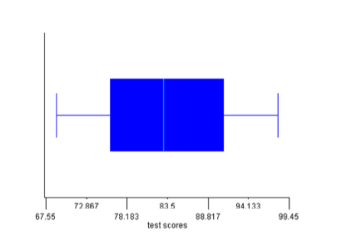

2 points: Exemplary response; box-and-whisker plot titled; lower extreme, lower quartile, median, upper quartile, upper extreme correct; explanation of usefulness correct.

1. point: 3-4 of the above elements are correct.

0 points: none of the above elements are correct.

1. Example answer: Make a bar graph and don’t start the y-axis counting at “0”, make a bar graph and don’t use consistent intervals, make a picto-graph and use distorted pictures.

2 points: Exemplary response; 2 correct methods explained.

1 point: 1 correct method explained.

0 points: No correct method explained.

1. Example answer: 0,0,1,1,2,2,2,4,4,4,4

2 points: Exemplary response; both mode and median are correct for set of data given.

1 point: Either mode or medians is correct, but not both.

0 points: Neither mode or median is correct.