Mathematics
Power Standard 7:10
Summative Scoring Guide

- A
- B
- Sample Answer:
Types of Movies
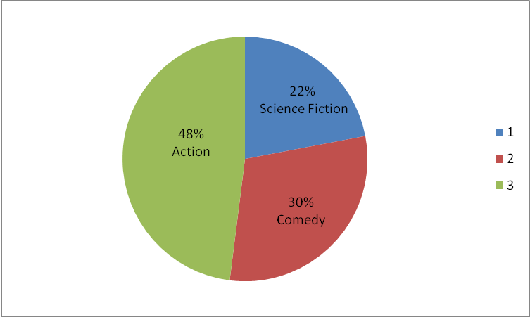

Key Elements: Graph is titled; sections on circle graph are correct size (degrees); sections on circle graph have labels with category and percent

3 points: Graph contains all 3 key elements.
2 points: Graph contains 2 key elements.
1 point: Graph contains 1 key element.
O points: Graph contains no key elements.
- B
- 37.5; 34; 56; 37
4 points: Exemplary response; all 4 measures correctly given
3 points: 3 measures correctly given
2 points: 2 measures correctly given
1 point: 1 measure correctly given
0 points: no measures correctly given
- 26 students
2 points: Exemplary response; correct answer and work given
1 point: Correct answer OR correct work given
0 points: Neither correct answer nor correct work given
- D

