Mathematics

Power Standard 7:10

Pretest

Name __________________________________________________________ Hour __________

1. Maria wants to make a graph of her daughter’s height from birth to age 10. What type of graph would best represent Maria’s data?
2. line plot
3. line graph
4. circle graph
5. stem and leaf plot
6. What is the difference, in dollars, between the biggest and the smallest paychecks based on the graph below?

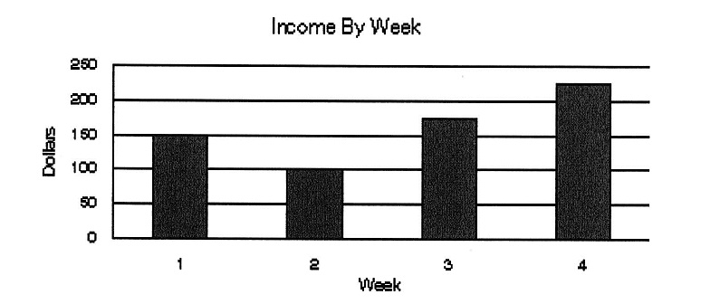

1. 125
2. $75
3. $150
4. $100

|  |
| --- |
| Test Scores |
| 98 90 97 85 86 92  92 93 95 99 91 92  91 94 88 90 93 92 |

1. Make a line plot for the following data.

1. Which measure of central tendency is most affected if the set of data has an outlier?
2. mean
3. median
4. mode
5. range
6. Find the mean median, mode, and range of the following data. Round to the nearest tenth, if necessary.

14, 5, 16, 7, 4, 15, 9, 7, 2, 14, 6

1. The graph below shows the ethnicity of Macon Middle School students. If there are 850

students at the school, how many of them are Hispanic?

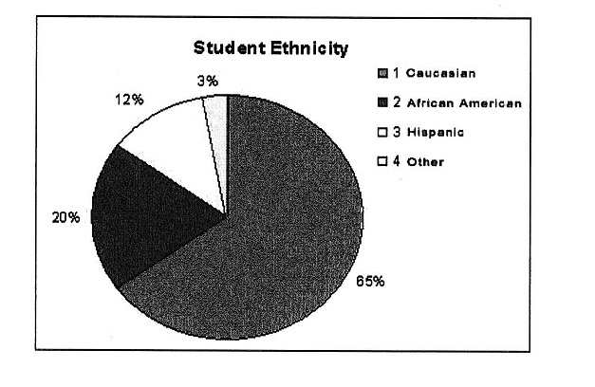

1. A circle graph shows that 45% of students in the U.S. are in grades K-8. How many degrees would this section of the circle graph be?

A. 45˚

B. 90˚

C. 162˚

D. 180˚