Mathematics

Power Standard 7:11 an d 7:12

Formative Test

Name __________________________________________________________ Hour __________

1. What is the diameter of a circle if the radius is 14 m?
2. 28 m
3. 7 m
4. 88 m
5. 14 m
6. A hamster’s running wheel has a radius of 3 in. What is the running wheel’s circumference rounding to the nearest tenth? Use 3.14 for $π$.
7. Find the area of the face of a Sacagawea $1 coin if the diameter is 26.5 millimeters. Round to the nearest tenth and use 3.14 for $π$.
8. Find the surface area of the rectangular prism with a length of 5 ft, a width of 3 ft, and a height of 9 ft.
9. Find the volume of the rectangular prism below.

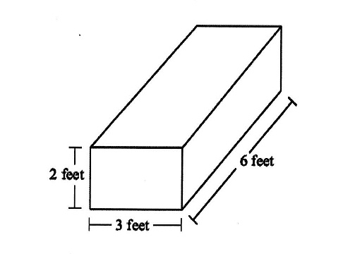

1. Find the surface area of the triangular prism below.

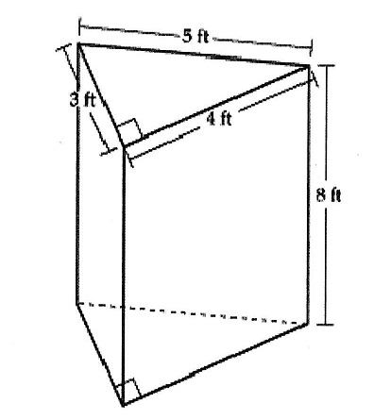

**Note: The figure is not drawn to scale.**

1. Find the volume of the right triangular prism below.

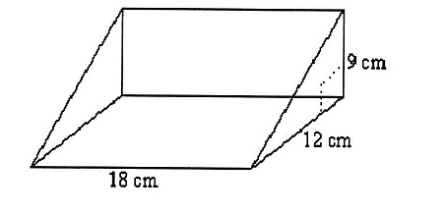

1. 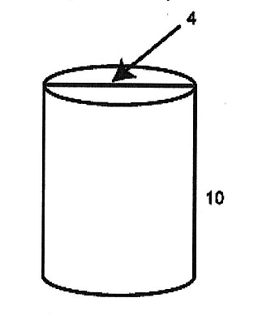Find the surface area of the cylinder below. Use 3.14 for $π$. Round to the nearest tenth, if necessary.
2. Find the volume of the potato chip can below. Use 3.14 for $π$. Round to the nearest tenth, if necessary.

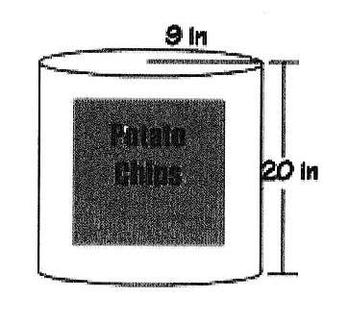

1. 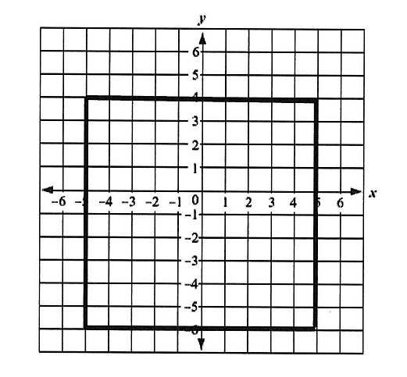The following graphed figure is a:

1. square
2. rectangle
3. rhombus
4. both a and b
5. Makayla drew a pentagon and the first four points of a second pentagon at (-7, -6), (-7, -4),

(-5, -4), and (-5, -6). Her work is shown below.

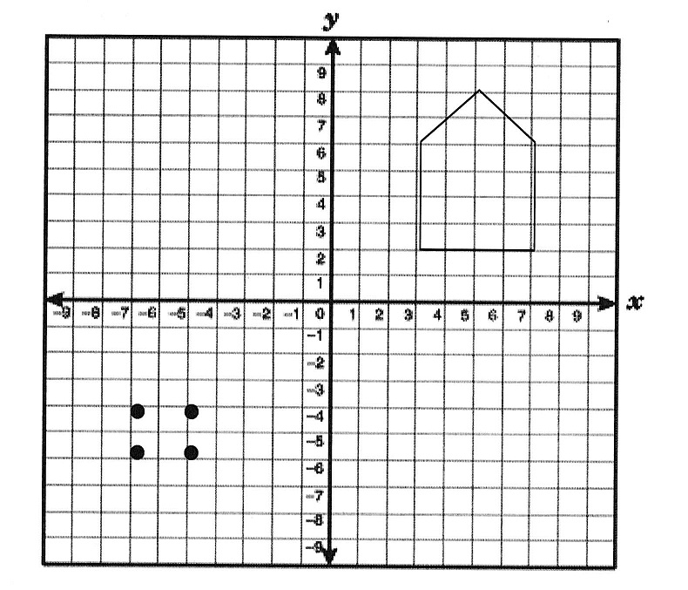

If she wants her new figure to be similar to the original, where does Makayla need to draw the fifth point of her new pentagon?

____________________________________________________________________________

1. The following figure has how many lines of symmetry?
2. 0
3. 1
4. 2
5. 3