Assign each student
a particular netbook
Can track student behavior
No “I saved it on another
computer” issues

Use collaborative tools
like Google Docs
Students want to share work
Collaboration is a key 21st century skill

Use multimedia capabilities
Podcasts
Videos
Interactive websites

Make expectations clear
Don’t turn kids loose
Model, model, model
Create a website for daily links/activities (Posterous)

Realize limitations of the netbook
Limited processing power
Internet bandwidth issues

Start small, and build up over time
Walk before you run
Push yourself just over your comfort level

Don’t use netbooks just for the sake of using them
If technology isn’t needed, unplug!
Bad Lesson + Netbook = Bad Lesson

When bad things happen
When in doubt, reboot
Maintenance is essential
Always have an offline backup plan

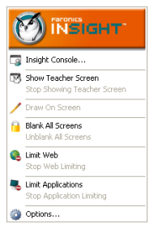
Show Teacher Screen – the student screen becomes a copy of the teacher’s screen. Useful if you don’t want to be tied to the SMART board.
Blank All Screens – each student screen goes blank, mouse and keyboard lock, etc. A good way to get kids’ attention focused on you for clarifications or further instruction.
Limit Web – You can turn off all web browsing, or limit students to a particular web page (like Google Docs, for example). Should probably be the default unless students are doing research, etc.
Limit Applications – Can disable all applications (Word, Powerpoint, other installed programs) so students can’t be doing what you don’t want them to do.
Other Insight features include:
Show a Student’s Screen 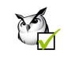Student Voting
Run a Program Shut Down, Log Off, restart

Detailed training from Tiger Tech last year is available at http://data.willardr2.net/co/tech/insight.html

Moodle has a steep learning curve, but can be a very powerful tool for instruction on your netbooks. The first step is to create an account at http://moodle.willardr2.net. There, you can find some great training resources. It is recommended that you use Internet Explorer or Firefox when working in Moodle. I suggest having your own Moodle course open in one window, and watching the video in another, side by side, like this.
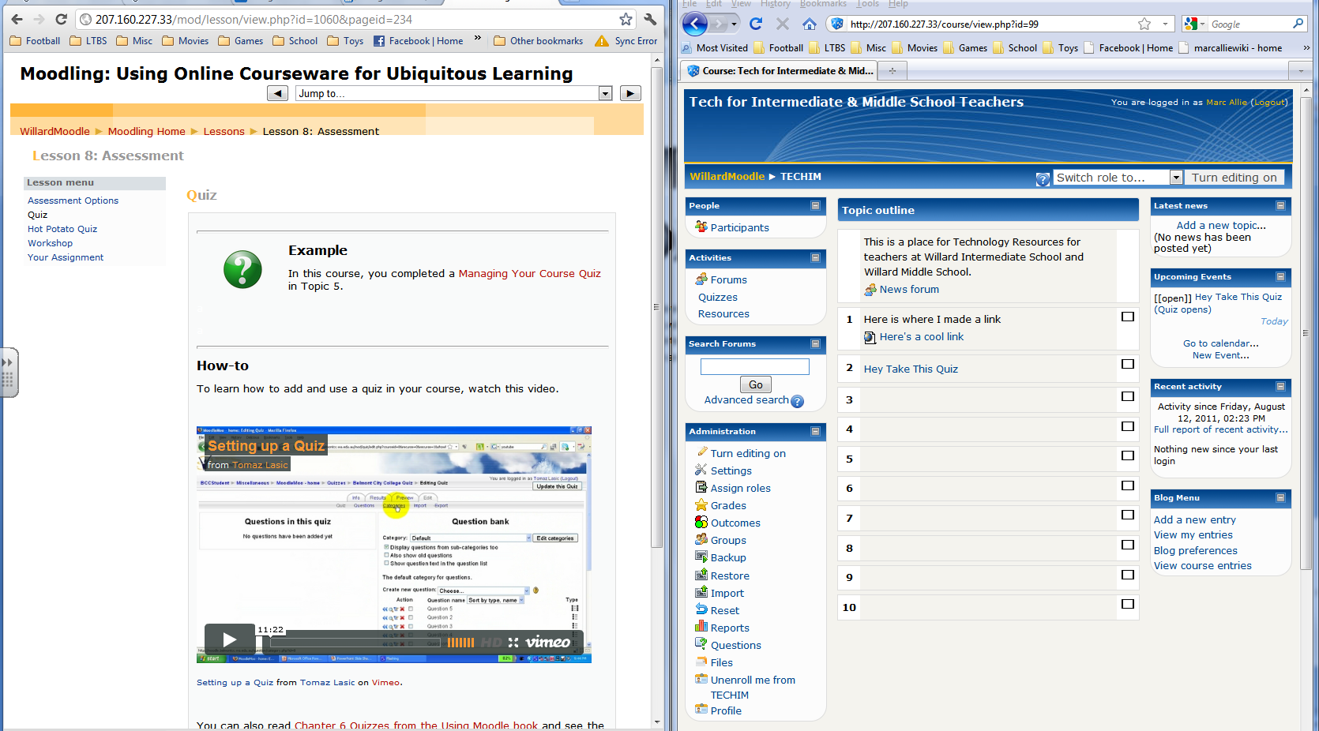

You can play the video in the left window, and work in the right window. Using videos this way is a great way to learn Moodle as you can pause, rewind, and watch something again, working at your own pace.

Here are a few particular items of interest. I will be scheduling further trainings in each of these topics in the next month or so. These will be hands-on sessions after school. We’ll cover quizzes on Wed. 8/24, and blogs and other resources Wed. 9/7. Of course, I am always available to meet with you individually during your planning time, before or after school, etc.
Creating a Quiz
http://vimeo.com/4963174
Setting up quizzes for your students is one of the best things you can do in Moodle. Moodle supports a variety of different types of quiz questions, including multiple choice, true/false, short answer, and even essay. Subjective quizzes are a bit harder to set up, but objective questions are a snap. Moodle grades the quizzes automatically and you can view a wide variety of reports based on quiz results.
Setting up blogs
http://vimeo.com/4963054
Another Moodle feature is the ability to allow students to create blogs. A blog (short for “web log”) can be used as a student journal, to turn in work, etc. Keep in mind that blogs are publicly viewable by all other members of a course, so don’t consider any blog private.
Adding RESOURCES
Links http://vimeo.com/4958995
Video clips http://vimeo.com/4961536
Other files http://vimeo.com/4956818
Perhaps the best part of Moodle is the ease with which you can add resources to your course. Web pages, pictures, videos, and many other types of files can be added to each topic. It’s a great way to keep organized and make sure that they can easily find exactly what they need.

