
- Log in to Stratalogica, then click on the “COMMUNITY” button.
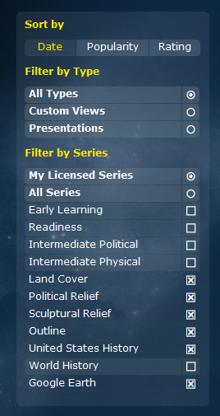
2. On the left side of the screen, click on the button next to “My Licensed Series”. This will display only the presentations and custom views that we have access to.
3. To find the best of the best content, click on the “Rating” button to display the highest rated presentations and custom views first.
3. Click on the preview picture to display the presentation or custom view.

4. When you find content you like, simply click on the “COPY TO MY GALLERY” button to add it to your gallery of presentations and custom views.

