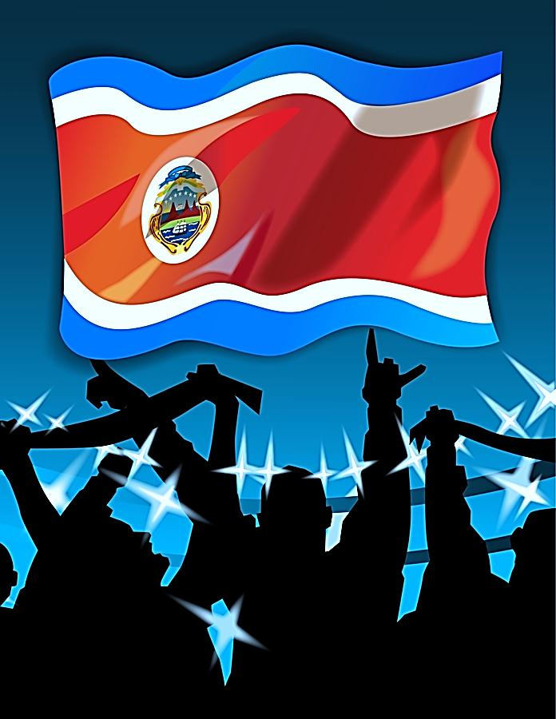

TEST YOUR TICO IQ

1. Las carretas in Costa Rica are carts pulled by oxen. They are painted in diseños tradicionales and smaller versions are very popular with the turistas that visit Costa Rica. You can see one in this classroom. What was their original function?

a. to transport the niños to school c. to bring coffee from the mountains to the ports
b. to employ the disabled d. to transport a bride to church on her wedding day

2. <<Ticos >> es el nombre para las personas de Costa Rica. How did they get this nickname?

a. They loved the British tradition of afternoon tea
b. It is from the Costa Rican custom to put an –ito or an –ico at the end of words
c. It came from the Costa Rican fútbol team.
d. It is from the Costa Rican habit of making a small “t” sound when they pronounce certain words.

3. Which of these is NOT a top export from Costa Rica:

a. automóviles made by Fiat & Mazda d. Intel microchips
b. café e. sugar cane
c. ferns f. bananas

4. What percent of Costa Rica’s land is protected in parques nacionales y reservas?

a. 26% c. 41%
b. 14% d. 20%

5. What major event happened in Costa Rica in 1968?

a. their president was assassinated c. they won their first gold medals in the Olympics in Mexico City
b. their president won the Nobel Peace Prize d. a volcano erupted that had been dormant for 400 years

6. The literacy rate of the ticos is:

a. 72% c. 96%
b. 88% d. 92%

7. Local diners and coffee shops in Costa Rica are known as:

a. cafeterias c. salones
b. sodas d. comedores

8. What is notable about the Costa Rican climate?
a. They only two seasons, dry and wet.
b. Their seasons are almost the opposite of ours due to Costa Rica’s proximity to the Equator
c. It is extremely hot there for most of the year
d. Trade winds cause several hurricanes each year

KEY

- Coffee is best cultivated in higher altitudes so “C” is the correct answer because long before the railroad and trucking, the carretas led by a team of strong, sturdy oxen could be counted on to get the café down the mountains via dangerously narrow pathways to the ports for exportation.

- We do the same thing in English but not to the extent of the ticos. We call Charles, Charlie and grandmother is “granny”. Costa Ricans love to put an –ito or an –ico on the end of the words as a term of endearment or just a charming way of speaking. They won’t drink café but instead will have a cafecito; their buddy is an amiguito; and they won’t have just a little of something, un poco, unstead un poquitico. So, “B” is the correct answer.

- Most of your tropical plants, including ferns come from Costa Rica. Dole Banana is known as “dole” (pronounce with Spanish accent); much of the animation developed for the first Shrek movie was with microchips manufactured in Costa Rica; Starbucks makes a fortune selling Costa Rican coffee, and their sugar cane makes it sweet. But there is no major automobile manufacturing in Costa Rica to date, so “A” is the correct answer.

- Costa Rica is smaller than Missouri. That makes the fact that just over a quarter of their country is held in biological reserves and national parks even that more impressive. “A” is the correct answer.

- In 1968, people were shocked by a major eruption of the volcano Irazú that had lay dormant for almost half a century. “D” is the correct answer.

- With one of the highest literacy rates in the world, Costa Rica attracts many international companies who prize their well-educated workforce. Costa Rica, at 96%, boasts an even higher literacy rate than the United States. “C” is the correct answer.

- While all of the words listed here are Spanish words for places to eat, the “sodas” are small, neighborhood cafés that serve excellent food at a low, low price. “B” is the correct answer.

- It rains from April to December. This is a less expensive time to travel in Costa Rica and everything is very lush and green. “A” is the correct answer.

Scoring:

0-3—You’ll need to pay attention as we learn more about Costa Rica or we’ll abandon you in the rain forest.

4-5 –No está mal-- You deserve a nice cup of Costa Rican coffee to celebrate!

6- Pura Vida! Your knowledge has earned you a ticket to go ziplining over some fantastic valleys in Costa Rica.

7—Impresionante! You’re deserving of an excursión to the black volcanic beaches of Costa Rica.

8—You are a real tico de corazón. Congratulations! You have just won a beautiful beach house on the Costa Pácifica.

